

Example

He Here we see the average values from the engineers report for a cold oil well in 2006. The Optivieiw well well monitoring hardware and software were implemented September 1st 2006.

 | Gas(kpa) | Torque(psi) | Speed (rpm) | Pump Eff (%) | Ontime (%) | Actions (Flushs, Loads) | Net Production (M3)
Jan-06 | 85 | 1100 | 110 | 48.48 | 93.5 | 4 | 233.12
Feb | 85 | 1050 | 110 | 42.03 | 96.4 | 4 | 202.1
Mar | 100 | 1050 | 110 | 32.48 | 83.3 | 5 | 125.96
Apr | 90 | 1100 | 110 | 30.3 | 33 | 2 | 65.8
May | Shut in 61 days waiting on rig ( Burn't pump )
June | 200 | 900 | 98 | 59.94 | 50 | 1 | 124.26
July | 140 | 1050 | 98 | 52.2 | 87 | 4 | 226.06
Aug | 90 | 1100 | 98 | 46.96 | 93.5 | 2 | 194.02
Averages | 112.85 | 1050 | 104.85 | 44.62 | 67.08 | 3.14 | 146.64
 | Optiview well monitoring equipment installed. (Sept 4th )
Sept | 19.1 | 1061 | 106 | 64.63 | 98.4 | 8 | 203
Oct | 20.8 | 1113 | 87 | 69.48 | 100 | 2 | 246
Nov | 29.7 | 1150 | 90 | 68.64 | 100 | 1 | 209
Dec | 29.3 | 1167 | 93 | 71.57 | 100 | 0 | 219.82
Averages | 24.72 | 1122.75 | 94 | 68.58 | 99.6 | 2.75 | 219.45

As you can see by the numbers not only was the net production increased by an average of
72.81 Cubic meters per month but the pump efficiency has also gone up by 23.96 %.

September was the trial month for us with this well. Working closely with the production foreman and studying the historical data helped us learn the best action to take to optimize this wells performance. Since then we have virtually eliminated servicing on this well. As you can see the last action done on this well was November 17th and the well hasn’t been flushed or loaded since.
March 27th 2007

Screen shot 1

Here is a screen shot of the well from Sept 1st to Sept 10th. As you can see the gas was very erratic which played a part of this wells troubles.

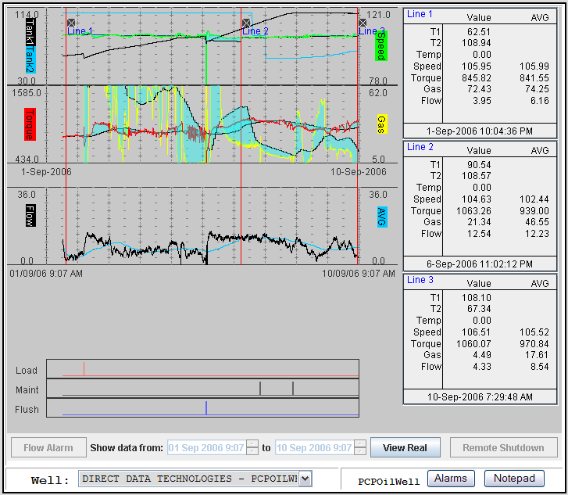

Screen shot 2

Here is the same well from Sept 10th to Sept 20th. Kimray valve installed Sept 10th. As you can see the casing gas is holding steady at 11 kpa allowing the well to flow consistently.

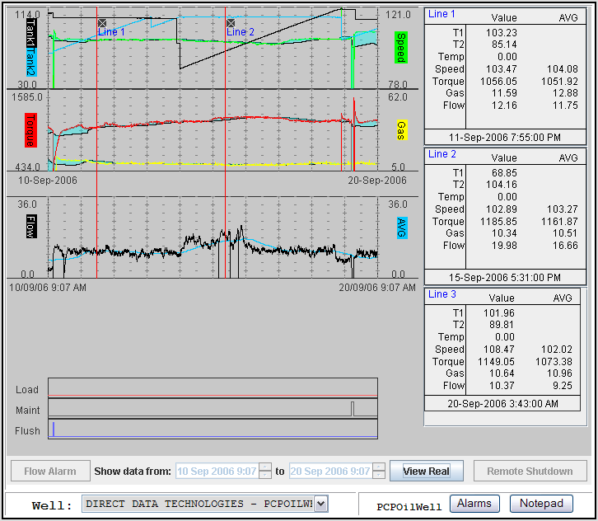

Screen shot 3

Here we see the well from Mar 21st to Mar 27th. In Line 3 you can see the values state the well to be making an average of 10.07 (M3) per day.

