

MTS Liquid Level Sensing. Direct Data Technologies has teamed up with MTS to allow us to stay on the cutting edge of technology. Along with our design team Direct Data has taken the M- Series Digital Flex Probe to the next level. With the easy no downtime installation through the thief hatch not only can we measure the three initial variables product level, interface level and tank temperature. But DDT has also added a high level foam float. Adding this with the alarming in our Optiview software we can also measure the sand level in the tank making this a five in one device!

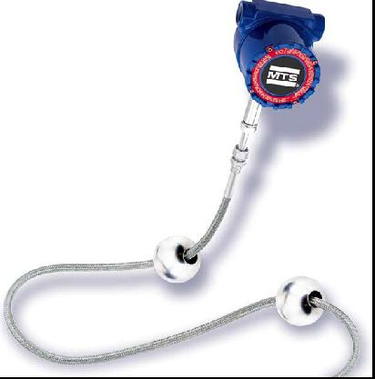
Advantages
- Know when to take a clean load of oil or water.
- Closer look at daily production.
- Easy installation.

Advantages with Optiview
- Alarms may be set for oil and water hauling.
- Alarm for sand level.
- 24hr trended water/oil cut.
- Mixed load alarm.
- Increased water cut alarm.
#2 4201 52nd St
Shown here is the MTS liquid level sensor with Lloydminster
Product and interface floats. Saskatchewan S9V 2B3
Phone (780) 800 0946

“ Work Smarter, Not Harder! ”

